**ELEE4033/4034**

**Robotics and Mechatronic Systems Engineering**

**Senior Capstone Design II**

**Winter 2018 (Term II, 2017-2018)**

Student: Enwei Xu, Zhongjian Sun, Zihang Wang, Chaoyi Hu, Xuan Yu

Student ID:T02133346, T02133274, T02133274, T02133232, T02133266

Student E-mail: (xuen, sunzh5, wangzi3, huch3, yuxu) @udmercy.edu

Instructor: Dr. Mariam Faied

Department of Electrical and Computer Engineering

College of Engineering and Science

University of Detroit Mercy

Date: April 25, 2018

**Contents**

Abstract 3

1. Introduction 4

1.1 The introduction of our robot 4

1.2 The motivation of the project 4

1.3 Objective of the project 4

1.5 Significance of the project 5

1.6 Importance of the technical portion 5

1.7 Hardware 6

1.8 imagination in the future 6

2. Hardware 7

2.1 Pioneer P3-DX 7

2.2 Product Features and Benefits 8

2.3 Pioneer P3-DX Core Software - included with all research platforms 9

2.4 Hokuyo 10

2.5 Kinect2 11

2.6 working principle 12

2.7 NUC6i7kyk 13

2.8 Platform, Stop Sign, traffic light 14

3. Software 16

3.1 Install ubuntu 16

3.2 ROS 16

3.3 ROSAria 18

3.4 Urg Node 22

3.5 Gmapping 27

3.6 Navigation: 32

3.7 install the drive of Kinect2 35

4. Conclusion 43

5. REFERENCES 44

Abstract

Our group’s goal is to make a self-drive robot, which can run in a setting map, there are some obstacles in this map, such as stop sign. We set the goal and start point to the robot. The robot can go to the goal by itself.

Our group did some work for the project. Made a board to install sensors and NUC. Connect the robot to the computer and use the keyboard to control the robot. Weld the wires for Hokuyo. We did the above based on what we have learned. We built a system which can achieve map making and wall avoidance by using Pioneer P3-DX. What’s else, we use slam_gmapping (Simultaneous Localization and Mapping), Navigation package ,Kinect2.

1. Introduction

1.1 The introduction of our robot

We make a system which can achieve map making and wall avoidance using Pioneer P3-DX. Pioneer P3-DX could do path planning, and go to the end point without going to the wrong way. Besides, whenever the Pioneer P3-DX is traveling in the maze, it would constantly correct its direction so as not to hit the wall. What’s more, our Pioneer P3-DX can detect obstacles in its path and maneuver around them without making any collision. It is fully autonomous and it does not need user intervention after loading the initial code. Even was placed in un- known environment with obstacles, the Pioneer P3-DX can work well. Then, our Pioneer P3-DX could successfully generate map files and allow for the additions of lines, goal points, and regions to the map. Upon detecting an obstacle in its path, it will stop to avoid collision. At the same time, the Pioneer P3-DX could determine a shortest path while avoiding obstacles. Our Pioneer P3-DX could create a clean and clear occupancy map, navigate through its environment, which is even full of obstacles, and is able to autonomously locate itself. In addition, the Pioneer P3-DX can be easily controlled to move by different methods including using keyboard.

1.2 The motivation of the project

With the progress of science of technology, Automatic driving technology has become an important direction of development in various countries. It is very convenient for people to use the technology of automatic driving. Google is the first company to research the automatic driving in the2010, and through the experiments to find that it is more safety than driving by people.

1.3 Objective of the project

The objective of our project is using knowledge, which we will learn, to make a simple automatic driving robot. This robot detect the environment to make a path by itself. From the start point to the end point, which we give the Pioneer P3-DX, the Pioneer P3-DX can run from the start point to the end point. In the path of the Pioneer P3-DX.

1.4 Division of work

Enwei Xu is the leader of the group. He did the software, such as installed the gmapping, navigation and connect the Kinect2 to the computer.

Zhongjian Sun did the hardware. He drew the draft in the solidwork and then used 3D printer to print the model of the stop sign and traffic light. He connected the kinect2 and hokuyo to computer by wire. When we need to write some paper or report. Zhongjian Sun organized the contributions.

Xuan Yu help Enwei Xu with the software about kinect2 and gmapping. He connected the wifi and the hokuyo at the same time.

Chaoyi Hu install the ROS.

Zihang Wang install the ROSaria.

1.5 Significance of the project

Our project is concentrate on finding obstacle, during the running, find the obstacle and avoid the obstacle. The research of the car is not our concentration. We add some sensors on the Pioneer P3-DX to make it find the obstacle, such as hokuyo and kinect2. Those sensors can receive the data from the environment, then change the path to go through the obstacle. The meaning of our project is sometime driver will feel tired or think in the wrong way to make the traffic accidents. But using the automatic driving can remind driver in the right time or automatic avoid the obstacle. Those will reduce the traffic accidents and help the drivers.

1.6 Importance of the technical portion

Some parts of our project are difficult, such as image recognition, we used the Kinect2 to receive the information and transfer to the computer. We used some color as the obstacle. We used Slam_gmapping which can solve at the same time positioning and map construction. the Pioneer P3-DX moves from an un- known position in an unknown environment. Then, we used Navigation package which is used to calculate the velocity for the Pioneer P3-DX to go to the destination. To create the connection of the Kinect to the computer, used iai-kinect2 package and libfreenect2 package to drive the kinect2, then using the rbx1 to distinguish the color.

1.7 Hardware

Our hardware plan let us use the microcomputer as a processor, and the sensors are the Hokuyo and the Kinect. Hokuyo is a LIDAR that can make our robot avoid the obstacles. The Kinect is the view sensor that can receive the data from the environment and transfer to computer.

1.8 imagination in the future

If the Pioneer P3-DX can receive the map, such as the google map. Lots of information can help the Pioneer P3-DX run in a large scope and know which road is crowded, so the Pioneer P3-DX can find the best choice to reach to goal. Then we can add more sensor behind the robot such as mechanical arm, light and so on.

1. Hardware

2.1 Pioneer P3-DX

The Pioneer P3-DX [1] is the world's most popular research mobile robot. The Pioneer’s versatility, reliability and durability have made it the reference platform for robotics research. Unlike hobby and kit robots, the Pioneer P3-DX includes a dedicated motion controller with encoder feedback, is fully programmable, and will last through years of tough classroom and laboratory use.  Whether you are monitoring the Pioneer P3-DX using mapping / localization or controlling it using teleoperation, getting it up and running out of the box is quick and easy.

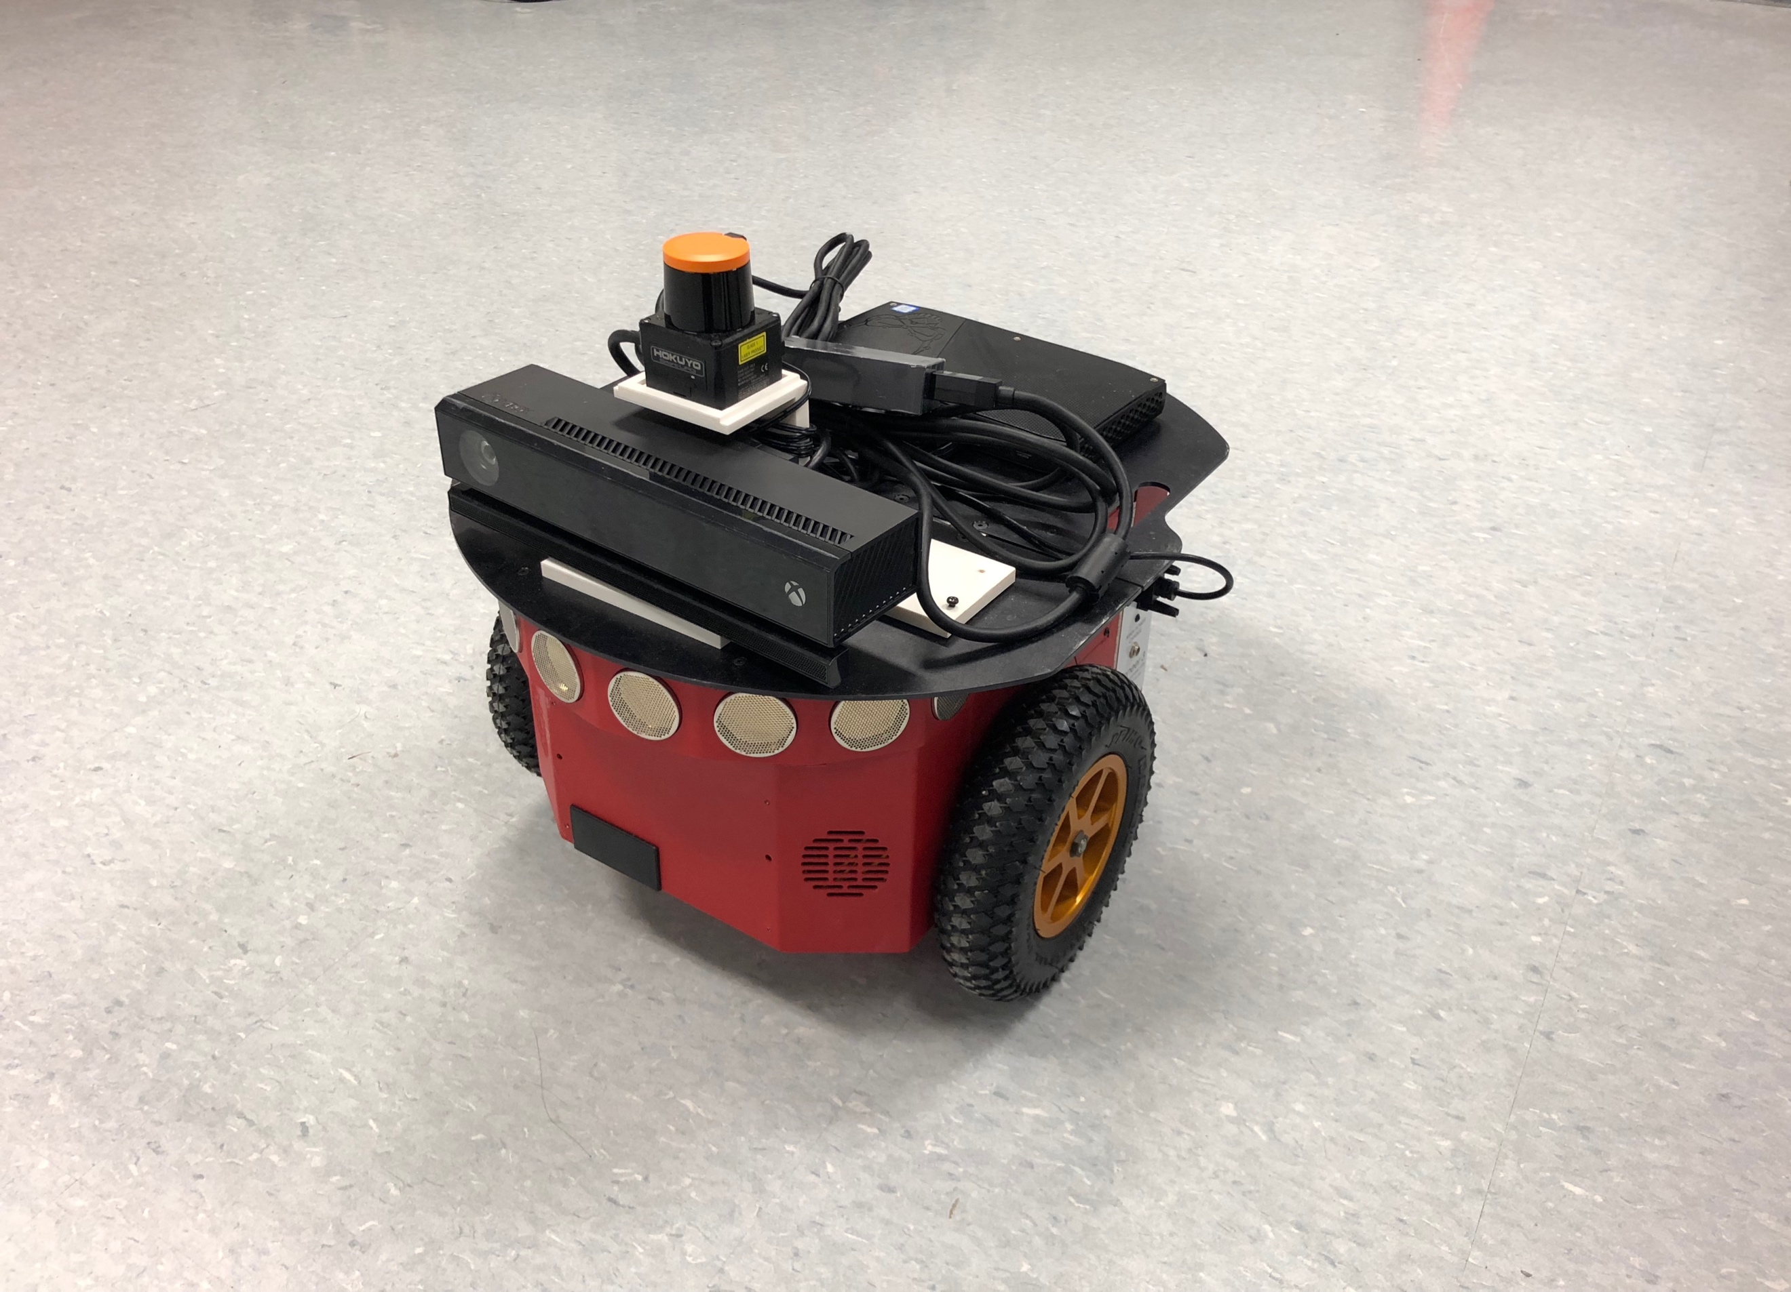

Fig.1. Pioneer P3-DX

Pioneer P3-DX is a compact differential-drive mobile robot. It arrives fully assembled with embedded controller, motors with 500-tick encoders, 19cm wheels, tough aluminum body, 8 forward-facing ultrasonic (sonar) sensors, 8 optional rear-facing sonar, 1, 2 or 3 hot-swappable batteries, and our complete software development kit. Add an optional internal computer or your own laptop and the robot is ready to go. Additional sensors, manipulators and other accessories are available to customize your Pioneer P3-DX for your specific tasks. We offer a wide variety of proprietary as well as 3rd party accessories fully integrated with your mobile base. Stereo and PTZ cameras for your vision robot applications and manipulators for your mobile manipulation needs are amongst our most popular options.

The base Pioneer P3-DX platform can reach speeds of 1.6 meters per second and carry a payload of up to 17 kg. The robot is powered by three hot-swappable 9Ah sealed batteries.

The robot's embedded motion controller automatically performs velocity control of the robot and provides robot state & control information including a position estimate of the robot in space (x, y, theta), battery charge data, and sonar range sensing data.  Your higher level control programs created with the Pioneer SDK can run on an onboard computer, or offline with the free simulator.

With the Laser Mapping and Navigation package, the robot can map warehouses, hangars, lab spaces, and any other indoor space in minutes; Accurately localize within the mapped indoor known space; autonomously navigate by planning and following dynamic paths to goals; and avoid obstacles along the way. The mobile platform is both your mapping robot as well as what you will use for autonomous indoor robot navigation.

2.2 Product Features and Benefits

• Easy to Use - Comes assembled and integrated with its accessory packages.

• Reliable - Construction is durable and rugged. Easily handles the small gaps, minor bumping, jarring, or other obstacles that hinder other robotic platforms. Some Pioneer robots have been in service for over 15 years.

• Pioneer Software Development Kit - All Adept MobileRobots platforms include Pioneer SDK, a complete set of robotics applications and libraries that accelerate the development of robotics projects. Pioneer SDK is backed by our product support team.

• Customizable - Easily accessorize by choosing from dozens of supported and tested accessories that integrate with the robotic platform. Additional help is available for future upgrades or added accessories.

• Reference Platform - Pioneer robots are a standard in intelligent mobile platforms. Search your preferred robotics journal or conference listings to find many examples of Pioneer platforms in research applications.

• Technical Support - Pioneer software and hardware comes fully documented with additional help available through our product support team.

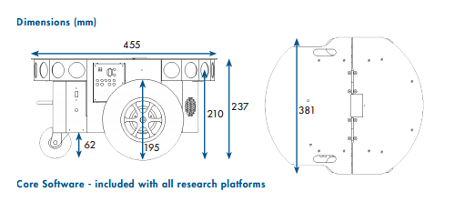

Fig.2. the size of Pioneer P3-DX

2.3 Pioneer P3-DX Core Software - included with all research platforms

ARIA provides a framework for controlling and receiving data from all MobileRobots platforms, as well as most accessories. Includes open source infrastructures and utilities useful for writing robot control software, support for network sockets, and an extensible framework for client-server network programming.

•MobileSim：open-source simulator which includes all MobileRobots platforms and many accessories.

•MobileEyes：graphical user interface client for remote operation and monitoring of the robot.

•Mapper 3-Basic：tool for creating and editing map files for use with ARIA, MobileSim, and navigation software.

•SONARNL：provides sonar-based approximate localization and navigation.

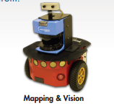 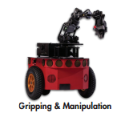

Fig.3. some kinds of Pioneer P3-DX

Accessory Support Software - bundled with purchase of robotic accessory

•ARNL ：enables robust, laser-based autonomous localization and navigation.

•Robotic ：Arm Support Pioneer arms are packaged with integrated software support.

•Speech Recognition and Synthesis Library: Easy-to-use C++ development library for speech recognition based on the open source Sphinx2 system. Speech synthesis (text-to-speech) based on Cepstral synthesizer.

•ACTS Color Tracking System: Software application which reads images from a camera and tracks the positions and sizes of multiple color regions. Information can be incorporated into your own software via ARIA.

2.4 Hokuyo

Laser Sensor: UST 10LX

Scanning laser rangefinder with 10-meter range, 12/24VDC, 25ms/scan, ±40mm, 270° scan angle, Ethernet 100Base-TX interface.

UST-10LX is a laser sensor for area scanning [2]. The light source of the sensor is class 1 infrared laser of wavelength 905nm. Scan area is 270º semicircle with maximum radius 10000mm. Pitch angle is 0.25º (1080 steps). Distance measurement is based on calculation of laser phase difference, from which it is possible to obtain stable measurement with minimum influence from object’s color and reflectance.

Hokuyo UST-10LX Laser Range Finder

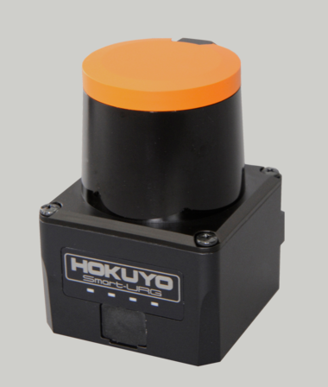

Fig.4. Hokuyo

APPLICATION

Navigation and obstacle detection (Guide path planning for mobile robots and autonomous systems)

Object positioning (control docking processes of AGVs, AGCs)

Object Profiling (cargo containers, pallets for loading & unloading)

Object measurement and detection (volume of packages, pallets, flow measurement of bulk materials)

Area monitoring (building security and entrance ways)

2.5 Kinect2

It is a 3D somatosensory camera (Development codename "Project Natal") [3], and it introduces features such as instant motion capture, image recognition, microphone input, speech recognition, and community interaction。

Players can use this technology to drive in games, interact with other players, share pictures and information with other Xbox players via the Internet, etc.

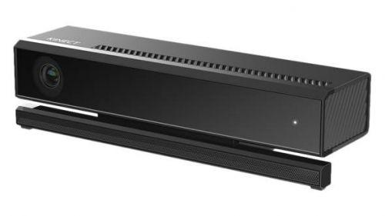

Fig.5. Kinect2

2.6 working principle

Natal has a powerful sensory array. For novices, it has a digital video camera. Can engage in many tasks such as capturing pictures to identifying colors. The microphone in Natal can collect multiple sound data in a short period of time in order to separate the player from other people in a room.

Of course, these kinds of intelligence cannot be separated from software support, and this aspect is Microsoft's strengths. The specially crafted software has trained Natal to successfully recognize the changes in the person's face details. In recognition of human motion, the accuracy can reach 4 centimeters.

In 2009, Microsoft acquired the Israeli company 3DV, giving people the impression that Natal's technology was derived from the 3DV ToF (time of flight) camera. The 3DV sensor requires a femtosecond shutter due to the time it takes to measure light. It is said that they use GaAs in their chips to increase their clock frequency to hundreds of G. However, doing so will increase its cost. It is difficult to imagine that Microsoft can put such technology into consumer electronics such as game consoles. In January 2010, Microsoft's developers made it clear that Natal is not based on the principles of ToF. In April 2010, another Israeli company (Israelis really bad) PrimeSense confirmed that Microsoft provided its three-dimensional measurement technology and applied to Project Natal.

The PrimeSense company's home page mentions that it uses a light coding technology. Unlike traditional ToF or structured light measurement techniques, light coding uses continuous illumination (rather than pulses) and does not require special sensor chips, but only ordinary CMOS sensors, which greatly reduces the cost of the solution.

Light coding, as the name implies, uses light source lighting to code the space that needs to be measured. In the final analysis, it is structured light technology. However, unlike the traditional structured light method, his source is not a cyclical two-dimensional image coding but a “body coding” with three-dimensional depth. This light source is called a laser speckle and is a random diffraction spot formed when a laser strikes a rough object or penetrates a frosted glass. These speckles have a high degree of randomness and change the pattern with distance. In other words, the speckle pattern at any two places in the space is different. As long as the structured light is marked in the space, the entire space is marked. Putting an object into this space allows you to know where the object is, just by looking at the speckle pattern on the object. Of course, the speckle pattern of the entire space must be recorded before this time, so the calibration of the light source should be done first. In the PrimeSense patent, the calibration method is this: At intervals, take a reference plane and record the speckle pattern on the reference plane. Assume that the user activity space specified by Natal is within a range of 1m to 4m from the television, and a reference plane is taken every 10cm. Then, we have saved 30 speckle images after calibration. When a measurement is needed, a speckle image of the scene to be measured is taken. This image is then cross-correlated with the 30 reference images we have saved. In this way, we will obtain 30 correlation images. The position of the object will show a peak in the correlation image. Stacking these peaks one by one, and after some interpolation, you get the three-dimensional shape of the entire scene.

2.7 NUC6i7kyk

The NUC6i7KYK is equipped with a 6th generation Intel® CoreTM i7 processor and Intel® IrisTM Pro graphics card to deliver maximum performance for intense gaming. We have created a new and unique look, plus a redesigned chassis that allows you to take full advantage of every Ghz on a quad-core processor without overheating — making the NUC6i7KYK always cool and cool.

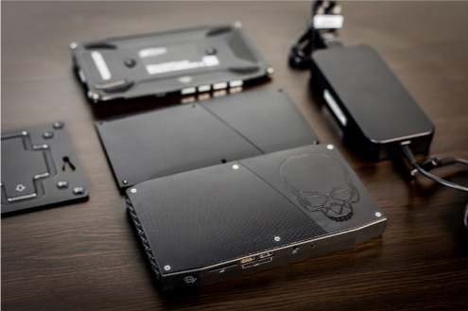

Fig.6. NUC

Features and Configuration:

1.6th Generation Intel® CoreTM i7-6770HQ Processor with Intel® IrisTM Pro Graphics (2.6 - 3.5 Ghz Turbo Boost, Quad-Core, 6 MB Cache, 45W TDP)

2.Dual Channel DDR4-2133+ SODIMM 1.2/1.35V, up to 32 GB

3.Intel® IrisTM Pro Graphics 580 1 HDMI* 2.0 (4K 60 Hz) 1 Mini DisplayPort* 1.2 (4K 60 Hz) 1 DisplayPort* 1.2 (via Type-C)

4.Up to 7.1 multichannel digital audio via HDMI or DisplayPort signals

3.5 mm front headphone jack, 3.5 mm rear speaker r/TOSLINK combo jack

5. ThunderboltTM 3 (40 Gbps) or USB 3.1 Gen2 (10 Gbps) via USB Type C connector

2 front USB 3.0 (one of them charging)

2 rear USB 3.0, 2 internal USB 3.0 and 2 internal USB 2.0 via connector

Consumer infrared sensor (front panel)

2.8 Platform, Stop Sign, traffic light

We use the 3D Printer to print the platform and the stop sign. And use the LED to make the lamp of the traffic light.

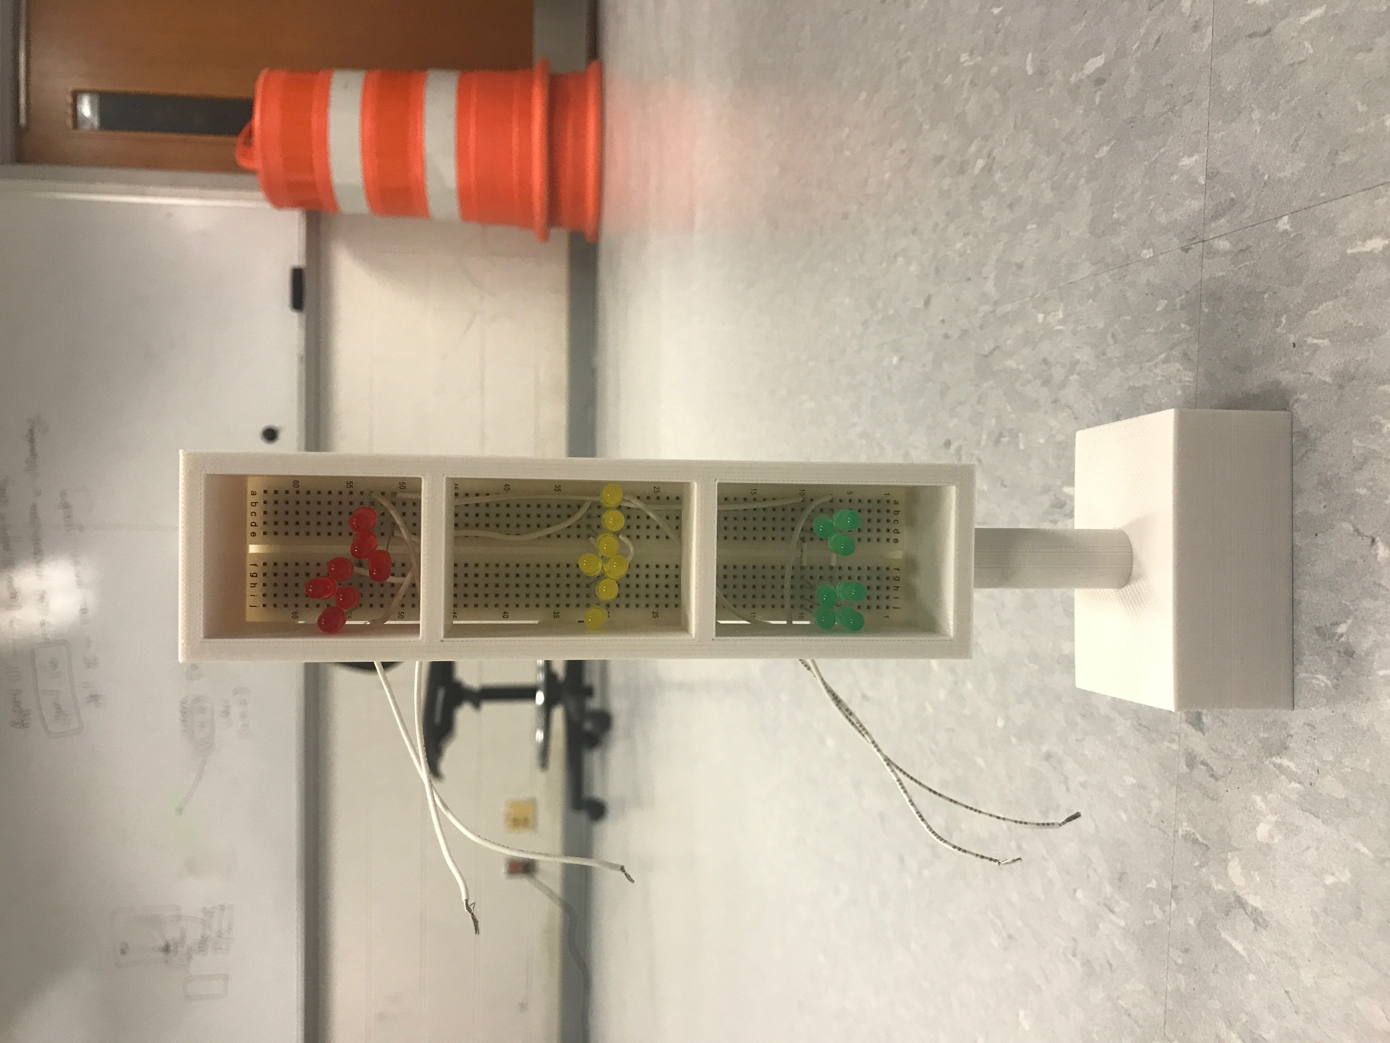 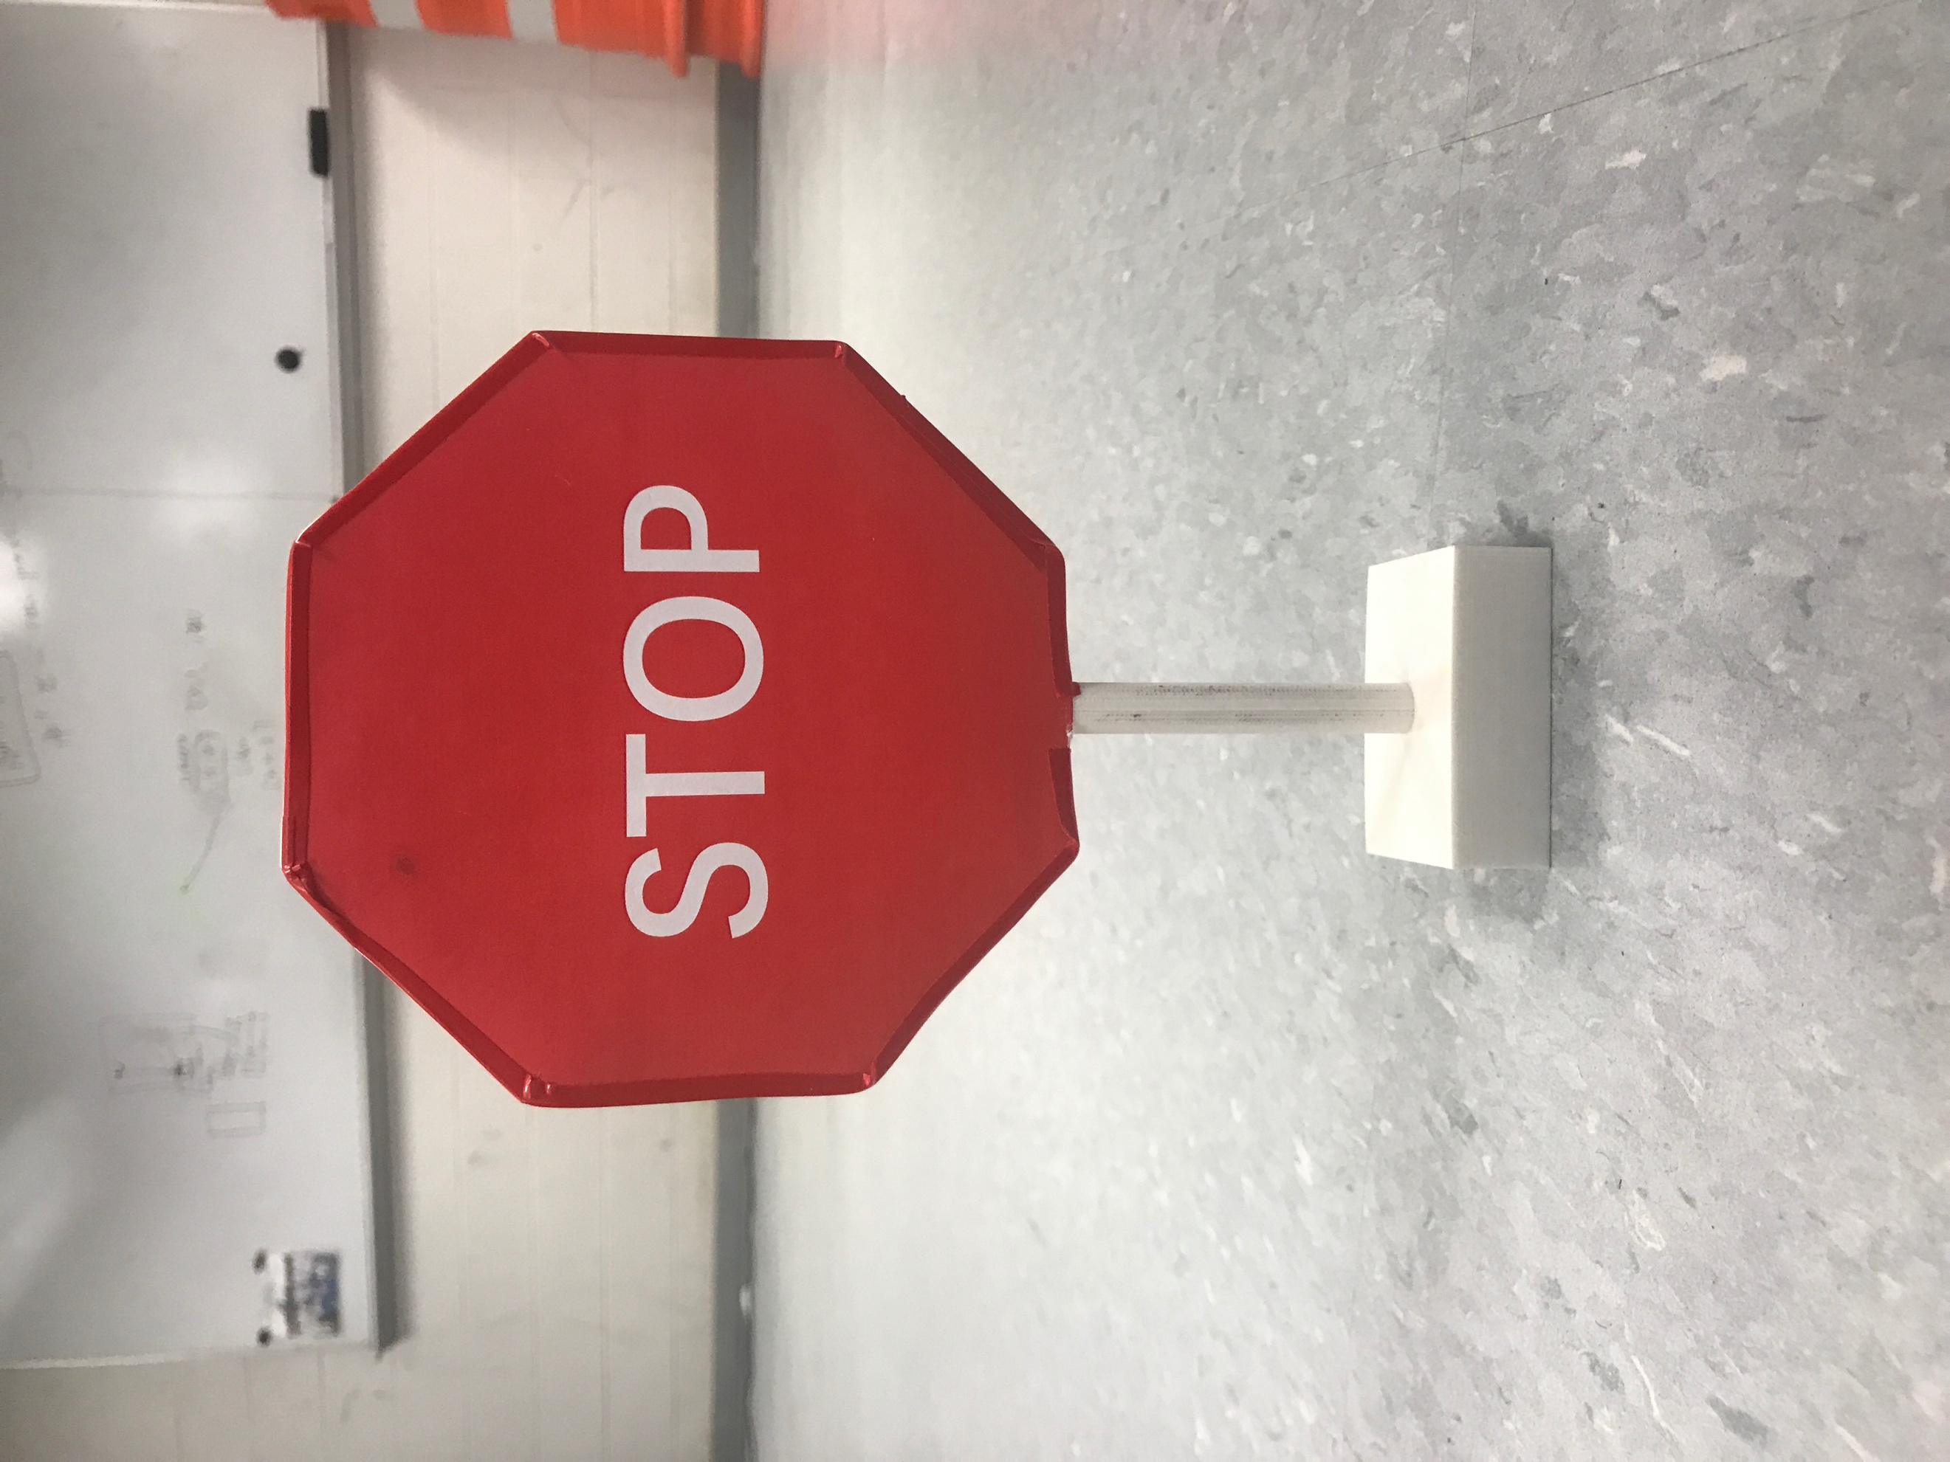

Fig.7. stop sign and traffic light

2.9 Connection

First we get the Pioneer P3-DX and then we need to use the screw opener to open the Pioneer’s platform and then we setup an voltage transformer to change the pioneer’s power to let it can afford the all hardware’s power.

Then we cut the hokuyo’s power wire and the Kinect power wire and use the welding gun to weld a connector on these two sensors and then use the new connector to let them connect with the Pioneer’s voltage. What’s more, we also connect the computer(NUC) to the Pioneer P3-DX and let it be the controlling center of the Pioneer P3-DX.

We put all the hardware on the platform that we made before. And all the hardware part is done.

1. Software

3.1 Install ubuntu

Ubuntu is an open source operating system for computers. It is a Linux distribution based on the Debian architecture. There are so many different version of Ubuntu system. For our NUC, we install Ubuntu 14.04 in it.

3.2 ROS

3.2.1 Ubuntu install of ROS Indigo

The whole project based on ROS. First, we install ROS on NUC. Because the system of the NUC is Ubuntu 14.04, we decided to install ROS Indigo for it. To install ROS successfully, we setup the sources.list which means that we setup NUC to accept software from packages.ros.org [4].

1) Setup your sources.list

$ sudo sh -c 'echo "deb http://packages.ros.org/ros/ubuntu $(lsb_release -sc) main" > /etc/apt/sources.list.d/ros-latest.list'

2) Set up keys

Then, we setup the keys.

$ sudo apt-key adv --keyserver hkp://ha.pool.sks-keyservers.net:80 --recv-key 421C365BD9FF1F717815A3895523BAEEB01FA116

3) Installation

After finishing that, we can install ROS desktop full version. This code is the desktop-full installation which includes ROS, rqt, rviz, robot-generic libraries, 2D/3D simulators and 2D/3D perception.

$ sudo apt-get install ros-indigo-desktop-full

4) Initialize rosdep

Before we can use ROS, we need to initialize rosdep. rosdep can make us install the system dependencies for source that we want to compile and is required to run some core components in ROS.

$ sudo rosdep init

$ rosdep update

5) Environment setup

The next step is to setup the environment for ROS. It's convenient if the ROS environment variables are automatically added to the bash session every time a new shell is launched

$ echo "source /opt/ros/indigo/setup.bash" >> ~/.bashrc

$ source ~/.bashrc

6) Get rosinstall

After finishing those steps, we can get rosinstall. rosinstall is a tool in ROS that is distributed separately. It can make us download many source trees for ROS packages with one command.

$ sudo apt-get install python-rosinstall

3.2.2 Creating Workspace

After we install ROS successfully, we need to create workspace. For installing ROSARIA and other supporting packages to run Pioneer P3-DX, we need to have a workspace in our NUC.

1) Set up shell environment

First, we should set up the shell environment to make the commands available.

$ . /opt/ros/indigo/setup.bash

2) Create a catkin workspace

Then, we create a catkin workspace. (The workspace directory may have any name.)

$ mkdir -p ~/catkin_ws/src

3) Change the working directory to our src folder

The above command is used to create a workspace directory and within that would appear a source folder named src. And then, we need to change the working directory to our src folder.

$ cd ~/catkin_ws/src

4) Initialize the workspace

The next step is to initialize the workspace.

$ catkin_init_workspace

$ cd ~/catkin_ws

5) Execute the build command using catkin_make command

After changing the directory to the catkin_ws folder, we can execute the build command using catkin_make command.

$ catkin_make

After executing the above build option, we now have three folders in our directory named build, devel and src. You can verify this using the $ ls command in the terminal.

Note that catkin_init_workspace must be run inside the src subdirectory, but catkin_make is used in the parent workspace directory. catkin_init_workspace only needs to be done once in the src directory.

Every time we want to use the catkin workspace to build packages, we must source the special devel/setup.bash script.

$ cd catkin_ws

$ . devel/setup.bash

3.3 ROSAria

3.3.1 Add the ROSAria package to the workspace

To install the ROSAria, we need to add ROSAria package to our workspace by downloading it from the GitHub website and copy them to the src folder [5].

$ cd ~/catkin_ws/src

$ git clone https://github.com/amor-ros-pkg/rosaria.git

3.3.2 Install ARIA and build ROSAria

To update the ARIA, we need to rebuild ARIA and check the version. If the version is wrong, we need to update it. ROSAria uses the Aria library from Adept MobileRobots to communicate with the robot. To install the latest version of ARIA, download it from <http://robots.mobilerobots.com/wiki/Aria>.

Install the ARIA package by opening it in the Ubuntu GUI, or use the dpkg tool on the command line with its -i option. For example:

1) for ubuntu 12 32 bit

$ sudo dpkg -i libaria_2.9.1+ubuntu12_i386.deb

2) for ubuntu 16 32 bit

$ sudo dpkg -i libaria_2.9.1+ubuntu16_i386.deb

3) for ubuntu 12 64 bit

$ sudo dpkg -i libaria_2.9.1+ubuntu12_amd64.deb

4) for ubuntu 16 64 bit

$ sudo dpkg -i libaria_2.9.1+ubuntu16_amd64.deb

Packages indicated for Ubuntu 12.04 can be used on any version of Ubuntu up to 16.04. To use an Ubuntu 12.04 ARIA package on Ubuntu 16.04, we need to recompile ARIA. For example: After installing the Ubuntu 12 package for ubuntu 14.04 version, enter the ARIA directory and rebuild ARIA:

$ cd /usr/local/Aria

$ make clean

$ make -j4

To check the version of python-rosdep package, we can also use rosdep to automatically install the ARIA dependency instead. But we should use the python-rosdep (>= 0.10.15) package. We use this command to check the version:

$ dpkg-query -W python-rosdep

If it's not the latest, this should update it:

$ sudo apt-get update

$ sudo apt-get upgrade

After checking the version and finishing all these steps, we use rosdep to automatically install the ARIA dependency.

$ rosdep update

$ rosdep install rosaria

3.3.3 Build ROSAria

Then, we build ROSAria using catkin. We run this command from the catkin workspace directory.

$ catkin_make

This will build all packages in the catkin workspace. We only need to install and build ROSAria once, or when changing to new versions of ROSAria or ARIA. Then close all the terminals.

3.3.4 Code Execution

1) Run roscore

Before starting any code with ros, open a new terminal and execute $ roscore command (Run roscore from ros workspace). Then ROS will be initialized in the computer.

2) Run the ROSAria node and get the IP address.

We run the ROSAria node from the ROSAria package and get the IP address of the host computer.

$ ifconfig

The following screenshot shows the output of the above command.

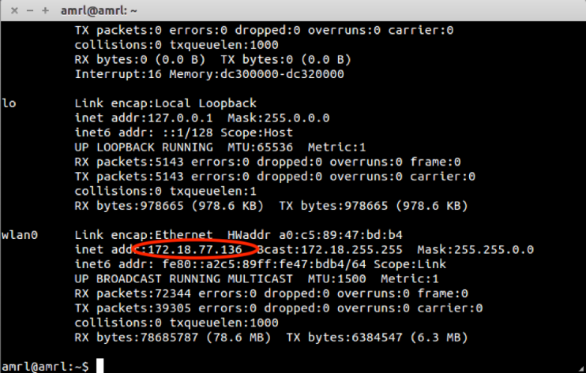

Fig.8. IP address of computer

$ export ROS_IP=172.18.77.136

3.3.5 Executing Client Programs

1) Go to the main workspace.

$ cd ~/catkin_ws/src

2) Extract the code from the github.

$ git clone https://github.com/pengtang/rosaria_client.git

3) Go one step backwards to the main workspace.

$ cd.. or $ cd ~/catkin_ws

4) Using catkin_make command build the workspace.

$ catkin_make

5) Roslaunch the ROSAria

Open a new terminal and type:

$ roslaunch rosaria_client rosaria_client_launcher.launch

Or we can do it sequentially as mentioned below: Open three tabs and type each command on each tab.

$ roscore

$ rosrun rosaria RosAria

$ rosrun rosaria_client interface

3.3.6 Running Pioneer P3-DX with keyboard

$ rosrun rosaria_client

$ rosrun rosaria_client interface

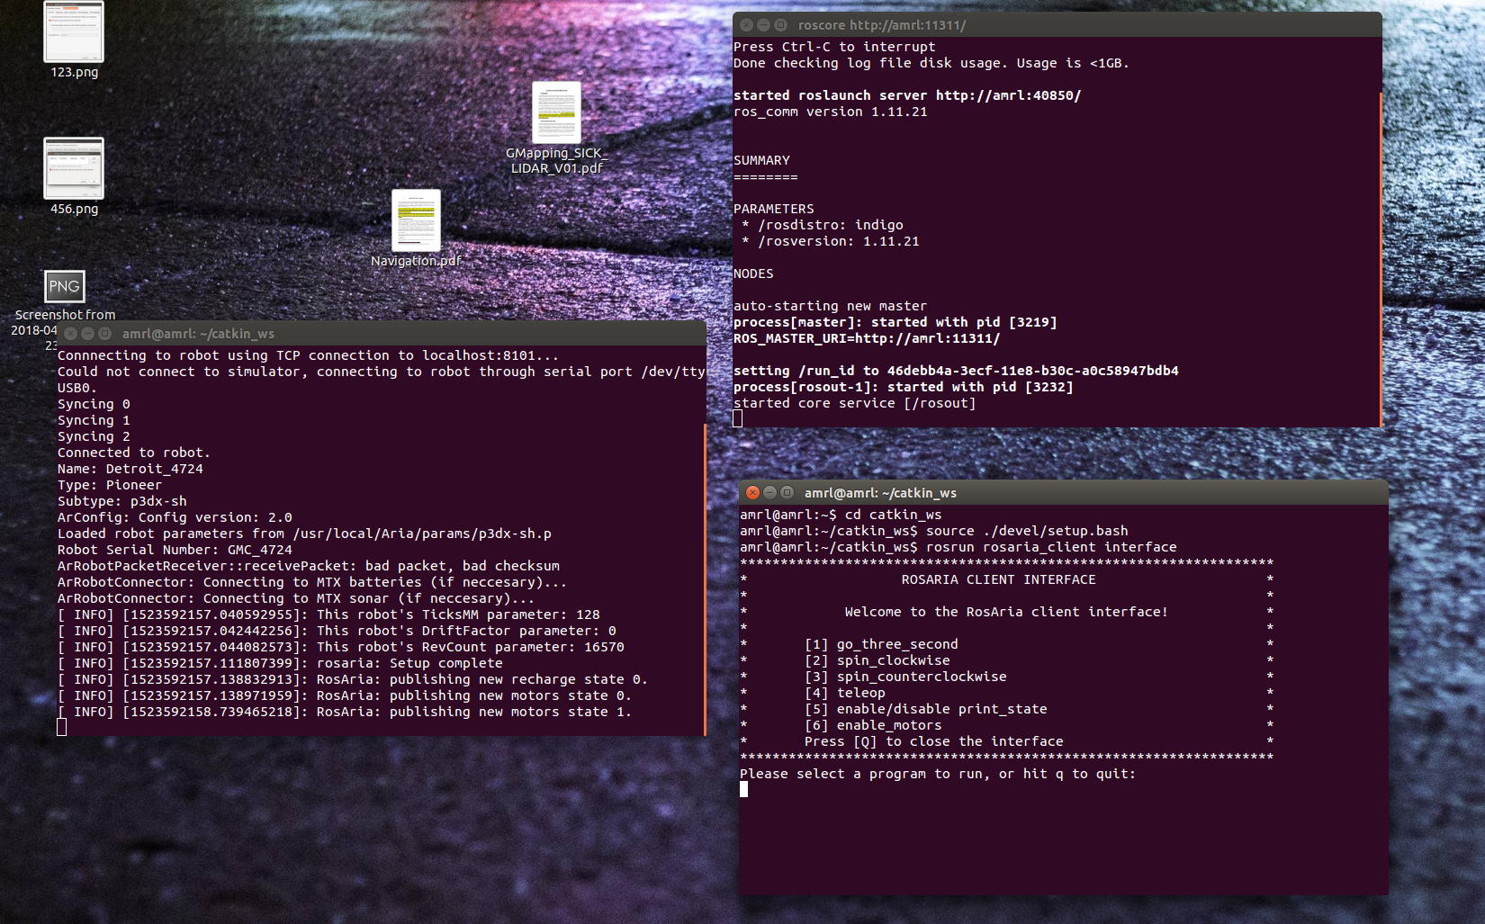

Fig.9. ROSAria client interface

Use up arrow for forward direction

Use down arrow for reverse direction

Use left arrow to turn left

Use right arrow to turn right

Type the alphabet “q” to quit

3.4 Urg Node

1) Clone the urg_node (which is the new hokuyo package) from github [6].

$ cd ~/catkin_ws/src

$ git clone https://github.com/ros-drivers/urg_node.git

2) Open the launch folder of urg_node, update the details of the file with the below details and save the launch file.

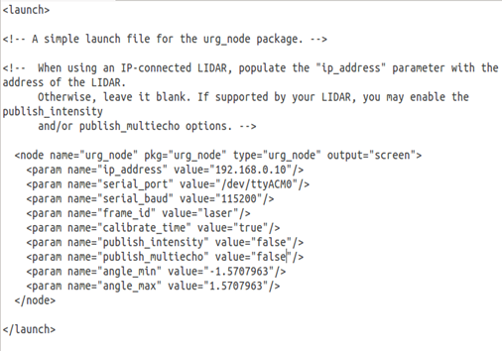

Fig.10. urg_node.launch

3) Update the network setting of the Ethernet port of the computer with the below details.

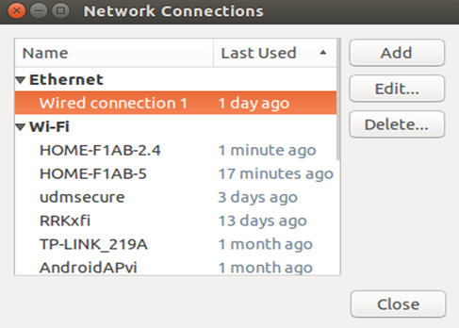

Fig.11. Network Connections

4) Select the connection under Ethernet (wired connection 1) and click the edit button. Select the IPv4 Settings and update the addresses as shown below. Save the settings.

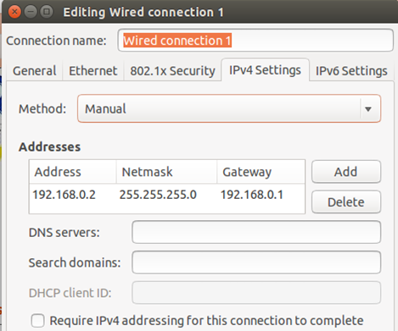

Fig.12. Edit wire connection

This command is used for connecting the hokuyo to the computer.

$ roscore

$ rosrun urg_node urg_node _ip_address:="192.168.0.10"

5) Open the rviz to see the LIDAR scan

$ rviz

Once the RVIZ opened, click on the add button, which is available at the bottom left side and from the create visualization window (as shown in figure), select a laserScan display type from it and click on OK button.

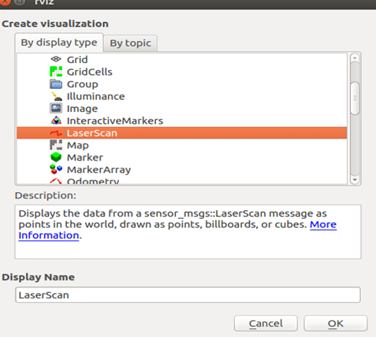

Fig.13. add display type

Then there is a picture in the rviz.

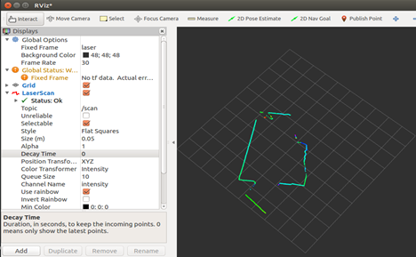

Fig.14. Rviz

When we connect the Hokuyo to our NUC, the Wi-Fi connection is lost. In order to fix this problem, so, firstly we search for Network Connections in the unity dash. Then, under the Ethernet section, click Wired connection 1. Under general section, change ‘Automatically connect to this network when it is available’ to ‘All users may connect to this network’.

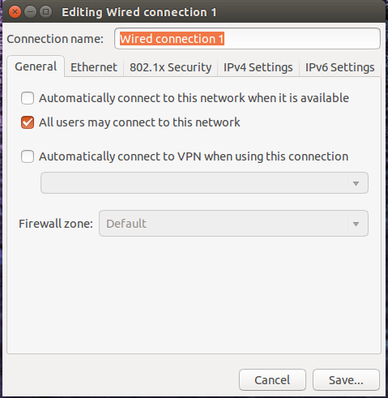

Fig.15. Setting connection

Then go to the IPv4/IPv6 settings and then click on the Routes button. Check the ‘Use this connection only for resources on its network’ option. Click Save. After doing all these steps, before connecting Hokuyo to the NUC, need to click the ‘Wired connection 1’to make it work.

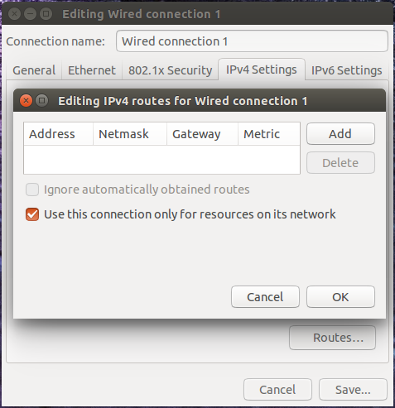

Fig.16. Setting connection

3.5 Gmapping

slam_gmapping（Simultaneous Localization and Mapping） contains a wrapper around gmapping which provides SLAM capabilities [7].

Robot Slam_gmapping can solve: At the same time positioning and map construction. the robot moves from an unknown position in an unknown environment, locates itself according to the position estimation and the map during the moving process, and simultaneously increases and establishes a map based on the positioning to realize independent positioning and navigation.

We installed the pioneer_bringup package from the website by using the follow command.

$ git clone https://github.com/amineHorseman/pioneer_bringup.git.

We use this package to get the data from pioneer. It can transfer data from rosaria. In the laser_lms1xx.launch, we can find some information: call the minimal.launch to get the odom data by RosAria. Using the hokuyo to get the laser data. tf is a package that lets the user keep track of multiple coordinate frames over time. tf maintains the relationship between coordinate frames in a tree structure buffered in time, and lets the user transform points, vectors, etc between any two coordinate frames at any desired point in time. We can write some nodes about tf in this launch file to create the relationship between two coordinates. For example, the pioneer will create a local coordinate. The follow picture will show the coordinate. The hokuyo will also send a coordinate. We should connect these two coordinates by use the tf node. We should change the tf node according to the position of the hokuyo on the pioneer. We add hokuyo and Kinect on the deck. We write the tf for zero to simulate the hokuyo and Kinect are at the origin of coordinates, because the Pioneer P3-DX is a small robot, so there is a little error. If we get a big robot, we will change the tf data [8].

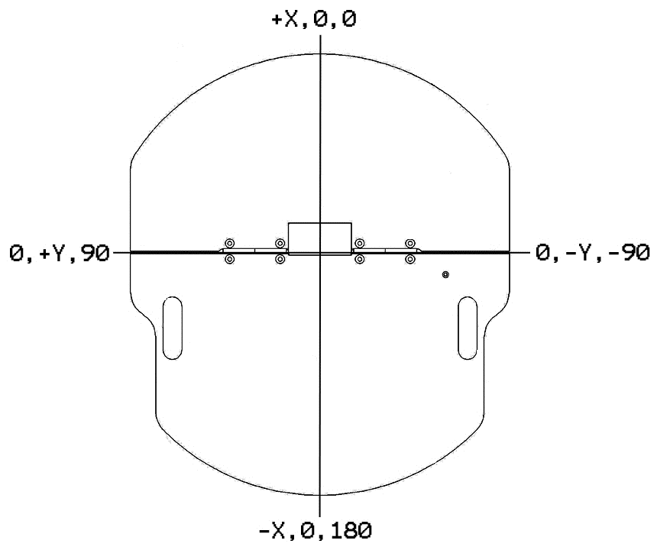

Fig.17. Internal coordinate system

We also need to install Lms1xx for ros by using the follow command.

$ sudo apt-get install ros-indigo-lms1xx.

Then we installed the slam_gmapping from the website by the follow command.

$ git clone https://github.com/ros-perception/slam_gmapping.

Then we changed some data in the launch files, which are suit for the user. There are some information in the slam_gmapping_pr2.launch. we can change the speed of updating for the map and the size of the map. When we use gmapping, we should experiment repeatedly to find the suitable parameters.

After we install the slam_gmapping successful, we run the follow commands in the terminals. First, open a new terminal. This command is for connecting the Pioneer P3-DX to the computer. When we receive streaming data. We connect successfully.

$ roslaunch pioneer_bringup laser_lms1xx.launch.

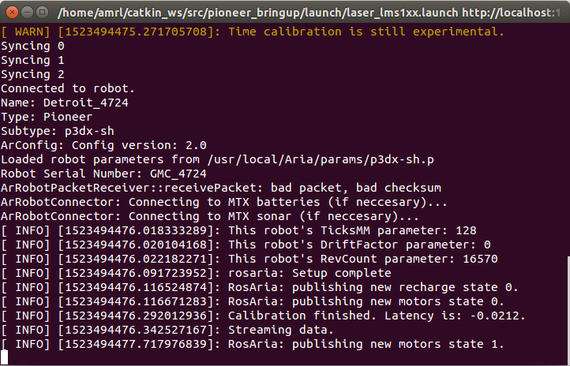

Fig.18. send to data to Pioneer P3-DX

Secondly, write the follow command in a new terminal.

$ roslaunch gmapping slam_gmapping_pr2.launch.

when we receive the first data, we run successfully. We need to run the Pioneer P3-DX, then we can receive the follow data, because, the procedure shows that the Pioneer P3-DX need to run some distance in linear or turn some angle to receive the data from hokuyo.

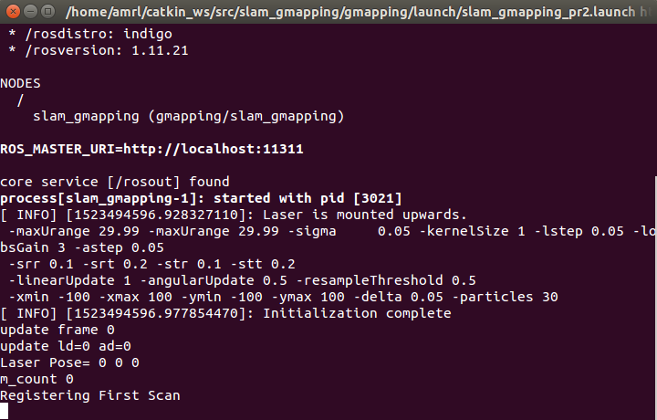

Fig.19. receive the data from slam_gmapping

Then open rviz. We can observe the map in the rviz. Create visualization by add map. If we want to see the coordinates, we will add tf. The fixed frame in the global options we choose map.

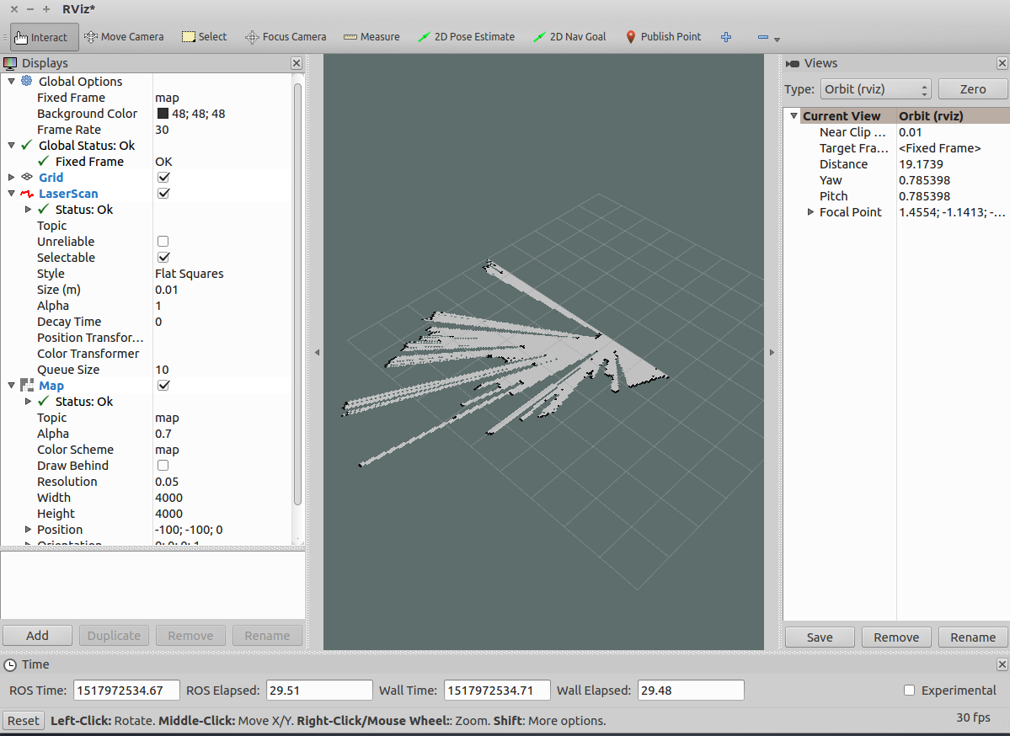

Fig.20. slam_gmapping in rviz

After those steps, we can find a part of the map in the rviz. The Pioneer P3-DX need to run to make a full map. We need to install a package to control the Pioneer P3-DX by keyboard by using command.

$ sudo apt-get install ros-indigo-teleop-twist-keyboard

We use the follow command in a new terminal to let the Pioneer P3-DX run. we can use the keyboard to control the Pioneer P3-DX.

$ rosrun teleop_twist_keyboard teleop_twist_keyboard.py.

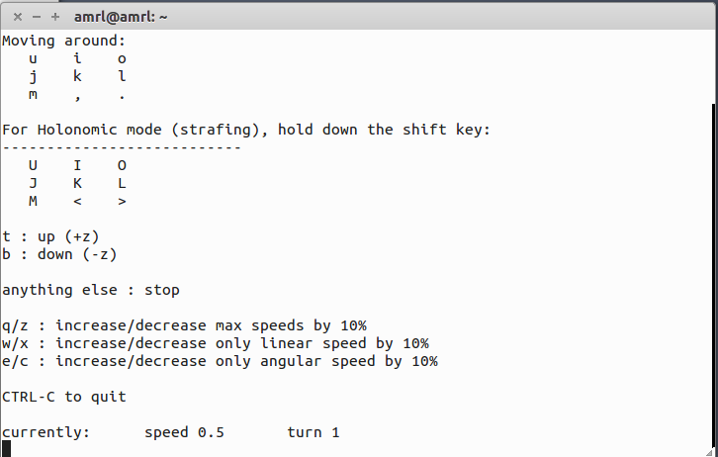

Fig.21. send speed to Pioneer P3-DX

This picture shows that we send the speed to Pioneer P3-DX.

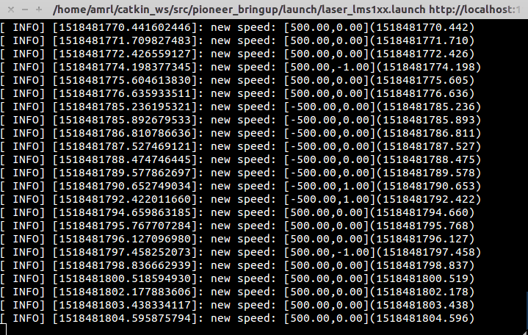

Fig.22. send speed to Pioneer P3-DX

When we scan the full map, we use the follow command to save the map.

$ rosrun map_server map_saver -f <map_name>

If we find some error that the computer cannot save the map, we will download the package for ros.

3.6 Navigation:

Navigation package is used to calculate the velocity for the Pioneer P3-DX to go to the destination. Input the odometry, lidar data, transfer information and map which is scanned in advance. Then the Pioneer P3-DX can get the cmd_vel velocity by using navigation package [9].

We need some packages for navigation, such as pioneerModel, p3dx_navigation. We downloaded from github by using the follow command in the catkin_ws/src folder.

$ git clone https://github.com/LCAD-UFES/p3dx_navigation.git

$ git clone https://github.com/LCAD-UFES/PioneerModel.git

Then, we need to use the follow command catkin_make.

In the src folder, we had many packages.

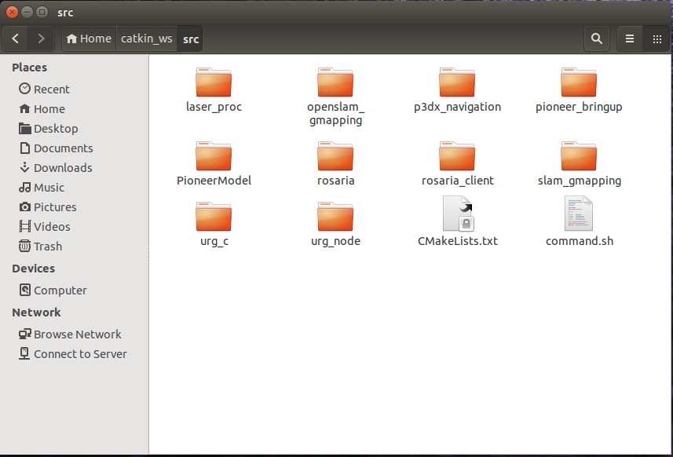

Fig.23. the package in the workspace

After, we saved the map, we need to add the map in the p3dx_navigation/maps. Then we changed the path of the map in the launch file.

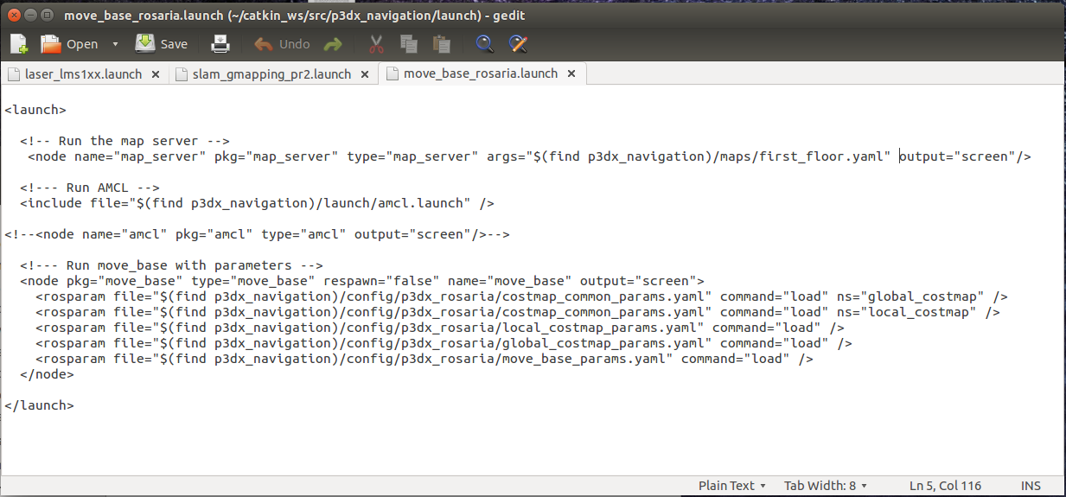

Fig.24. move_base_rosaria.launch

We changed all the laser data to the hokuyo, we copied the information from urg_lidar.launch, which is from urg_uode/launch, to the launch files in the p3dx_navigation.

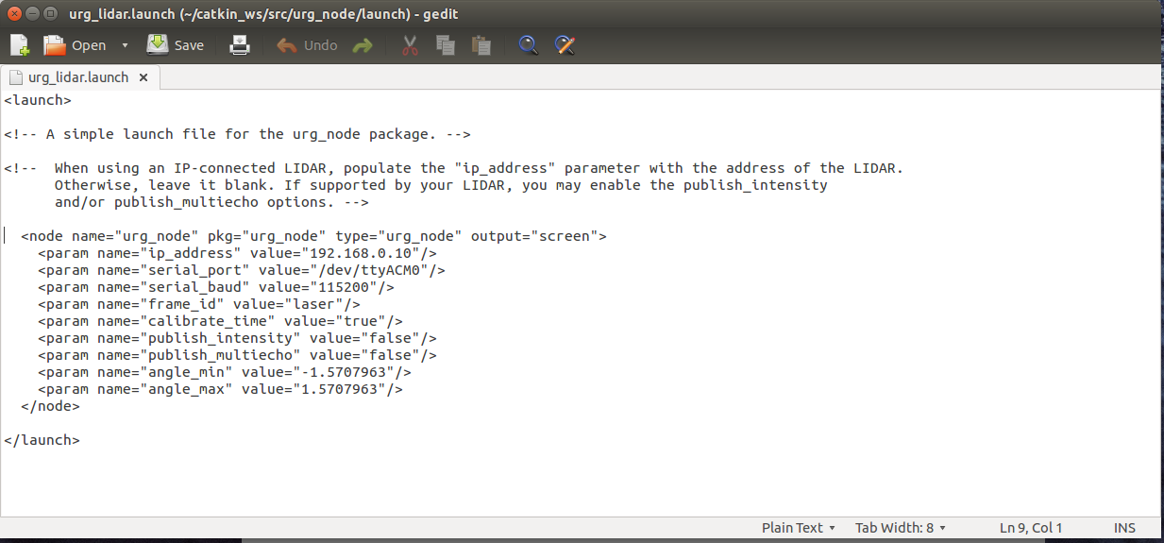

Fig.25. urg_lidar.launch

For changing the port. We opened the file named “pioneer.launch”, which was under /home/amrl/catkin_ws/src/p3dx_navigtion/launch. Inside this file, the below listed modification should be performed. The port address should be updated the ttyACM0 as well as the LIDAR details (LMS 1xx) in the file.

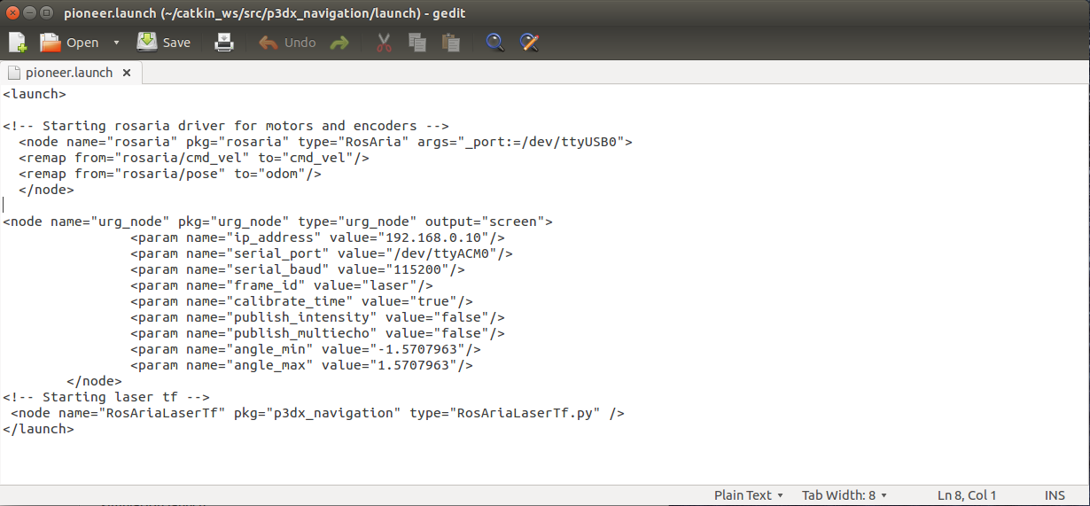

Fig.26. pioneer.launch

After those work, we tried to run the navigation, but it had something wrong with amcl launch file. Finally, we found that our ros does not have the navigation, so we downloaded from github, then, the problem solved [10].

We run three commands in the different terminal.

$ roslaunch p3dx_navigation pioneer.launch

This command connects the Pioneer P3-DX and LIDAR to the computer.

$ roslaunch p3dx_navigation rviz_p3dx.launch

This command will open a rviz.

$ roslaunch p3dx_navigation move_base_rosaria.launch

This command is used for uploading the map in the rviz.

In the rviz, we found our map, which built by gmapping.

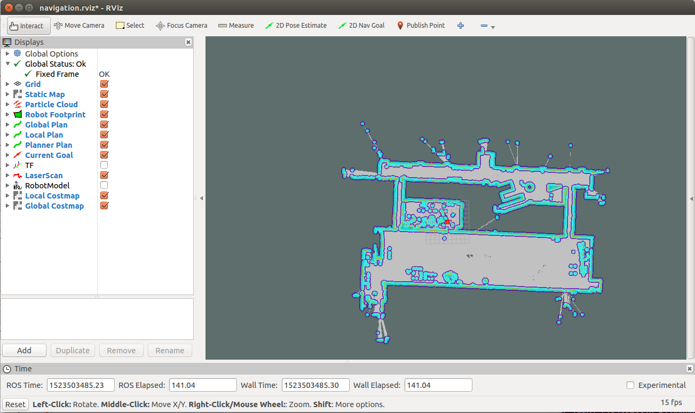

Fig.27. the whole map of first floor in the rviz

3.7 install the drive of Kinect2

We finished the gmapping and navigation, then, we used the kinect2 to receive the image data to distinguish the stop sign. The first thing we need to do was installing the drive of Kinect. We used libfreenect2 and iai_kinect2 packages. We followed the website[11]. We downloaded the packages from github, then, we downloaded the upgrade deb file in the libfreenect2 package.

$ cd libfreenect2

$ cd depends; ./download_debs_trusty.sh

Install the compile tool.

$ sudo apt-get install build-essential cmake pkg-config

Install the libusb.

$ sudo dpkg -i debs/libusb*deb

Install the TurboJPEG.

$ sudo apt-get install libturbojpeg libjpeg-turbo8-dev

Install the OpenGL.

$ sudo dpkg -i debs/libglfw3*deb

$ sudo apt-get install -f

Then, we built the package.

$ cd ..

$ mkdir build && cd build

$cmake .. -DCMAKE_INSTALL_PREFIX=$HOME/freenect2 -$ DENABLE_CXX11=ON

$ make

$ make install

We set the rules of udev.

$ sudo cp ../platform/linux/udev/90-kinect2.rules /etc/udev/rules.d/

After we connected Kinect2 to computer, we run the procedure.

$ ./bin/Protonect

We can find the image in the window.

Our group installed the iai-kinect2 package.

$ cd ~/catkin_ws/src/

$ git clone https://github.com/code-iai/iai_kinect2.git

$ cd iai_kinect2

$ rosdep install -r --from-paths .

$ cd ~/catkin_ws

$ catkin_make -DCMAKE_BUILD_TYPE="Release"

Then, we launch the kinect2_bridge kinect2_bridge.launch to get the data from kinect2.

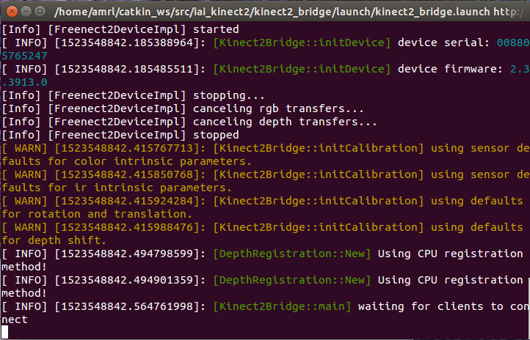

Fig.28. receive image data from kinect2

When we look at the rostopic list, we can find some topic.

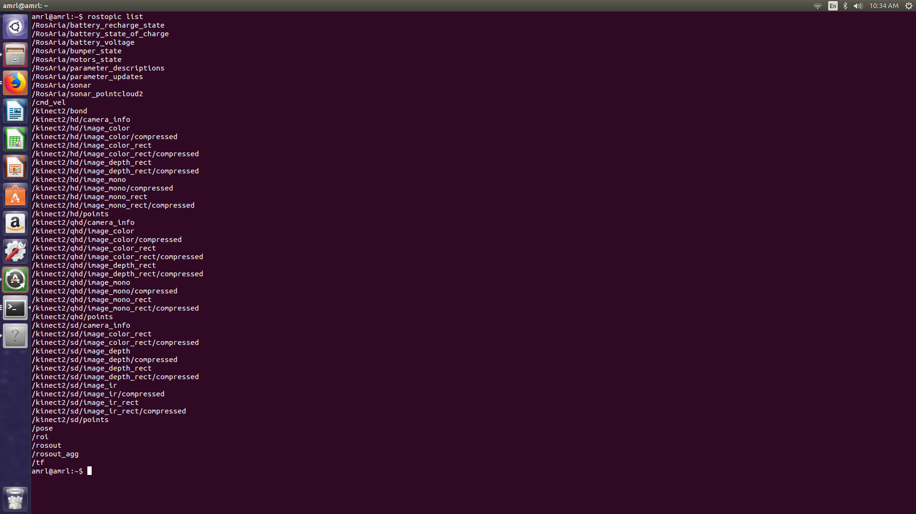

Fig.29. rostopic list

Finally, we installed the drive of kinect2.

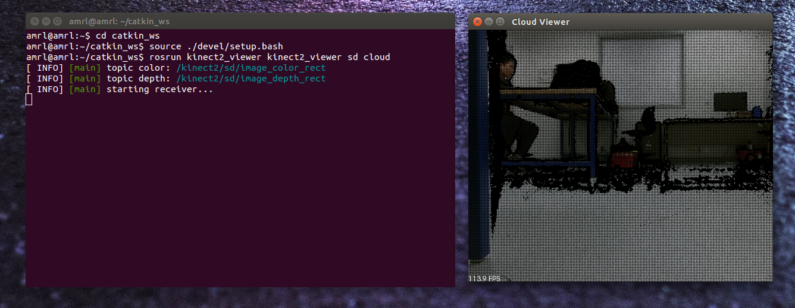

Fig.30. receive image from kinect2

Our group wanted to use the kinect2 to find the stop sign. At the first time, we wanted to use opencv surf algorithm to distinguish the image.

Libfreenect2 and iai-kinect2

Kinect2

Surf algorithm

eclipse

ROS

opencv

pioneer

This was our strategy. We wanted to use libfreenects and iai-kinect2 to receive the image data in the eclipse, then, we used surf algorithm and opencv to write some code in the eclipse. Finally, we could control the pioneer by the code. We find some problem, we did not know how to receive the data in the eclipse. For this strategy, we only can add opencv in the eclipse and open the picture.

The surf algorithm which extracts some unique key points and descriptors from an image. [12]

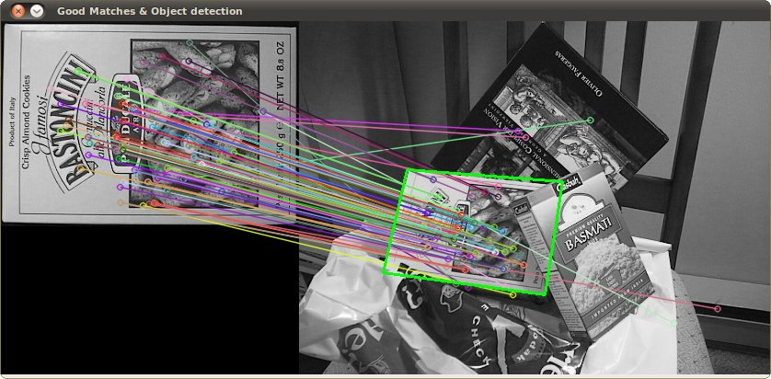

Fig.31. surf algorithm

A short description of what SURF does:

* Find interest points in the image using Hessian matrices
* Determine the orientation of these points
* Use basic Haar wavelets in a suitably oriented square region around the interest points to find intensity gradients in the X and Y directions. As the square region is divided into 16 squares for this, and each such sub-square yields 4 features, the SURF descriptor for every interest point is 64 dimensional.
* For a description of the 4 features, please refer the [paper](http://campar.in.tum.de/twiki/pub/Chair/TeachingWs09MATDCV/SURF_paper.pdf) – they are basically sums of gradient changes.

We can save an image, there were some key points in the image. When the kinect2 received the same key points as the image. We can find the goal.

Then, we changed the strategy, we downloaded a package called find-object. It also used surf algorithm to find the object. We can use it to distinguish the stop sign and traffic light.

After we find the object, we need to send speed to the pioneer. We found there is some error in our depth data and we cannot find the coordinate of the object in the rviz. We tried to solve the problem and wanted to find the data in the topic.

We found an useful package in the github called rbx1. This is a package for a book called ROS by example A Do-It-Yourself Guide to the Robot Operating System [13].

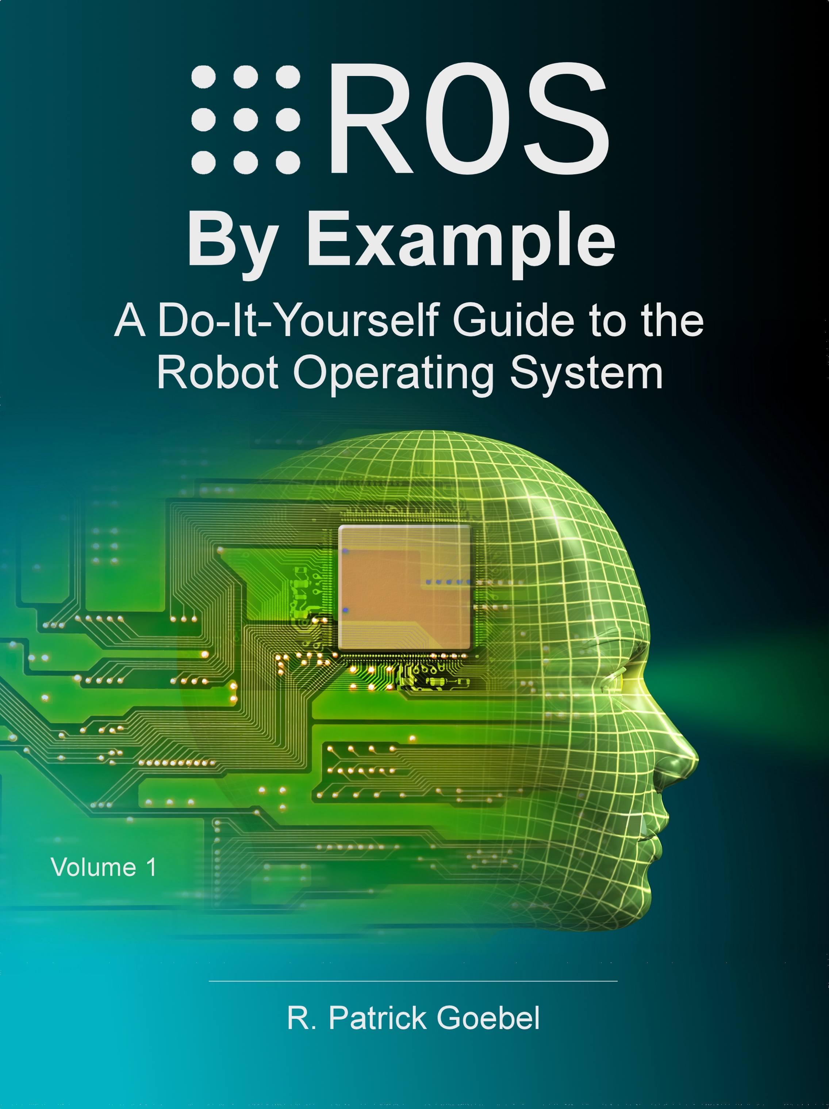

Fig.32. a book of ROS

We used rbx1_vision package, which used for following and tracking. Our strategy was using this package to find the stop sign and follow the stop sign, the Pioneer P3-DX will stop when the Pioneer P3-DX near the stop sign.

Install the rbx1 package [14].

$ git clone https://github.com/pirobot/rbx1.git

$ catkin_make

Then, we need to change some code in the launch files.

In the camshift.launch, we need to change as the follow.

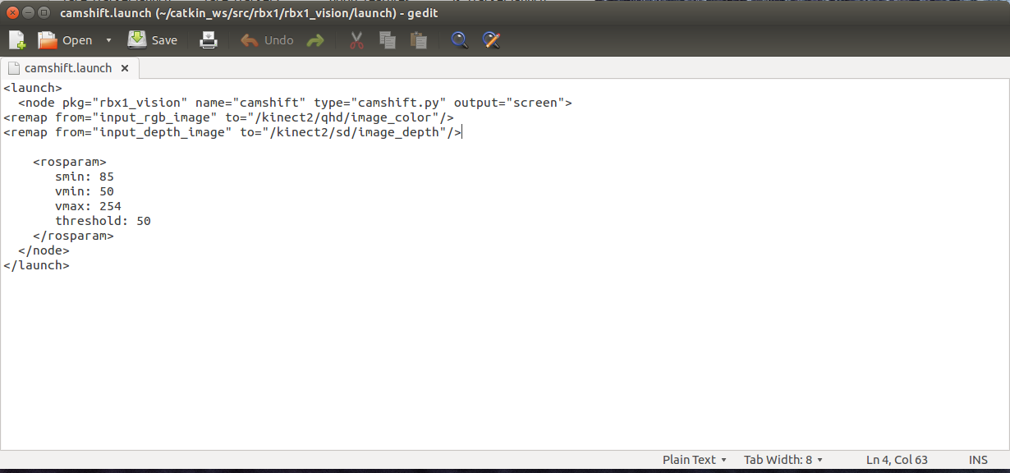

Fig.33. camshaft.launch

Also, we wanted the Pioneer P3-DX to follow the stop sign, so we change the follower2.launch as the follow.

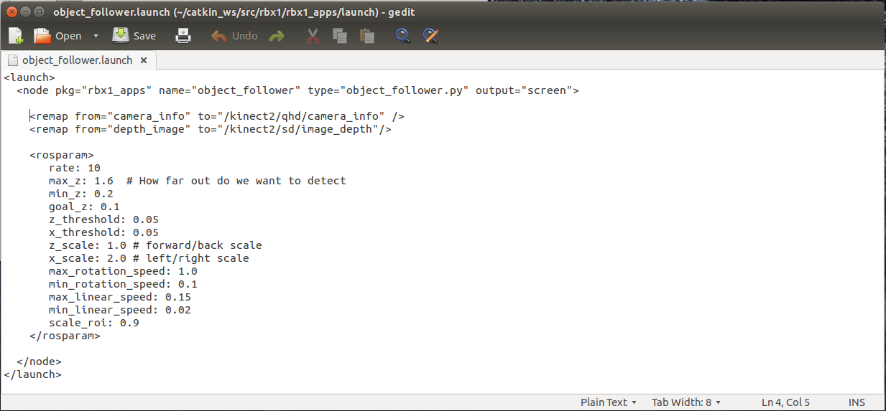

Fig.34. object_follower.launch

After those, we can run the follow commands to let the Pioneer P3-DX follow the stop sign.

$ roslaunch catkin_ws/src/pioneer_bringup/launch/mimimal.launch

This command is used for sending speed to Pioneer P3-DX.

$ roslaunch kinect2_bridge kinect2_bridge.launch

This command is used for receiving the data from kinect2.

$ roslaunch rbx1_vision camshift.launch

After, we run this command. We can see the follow picture.

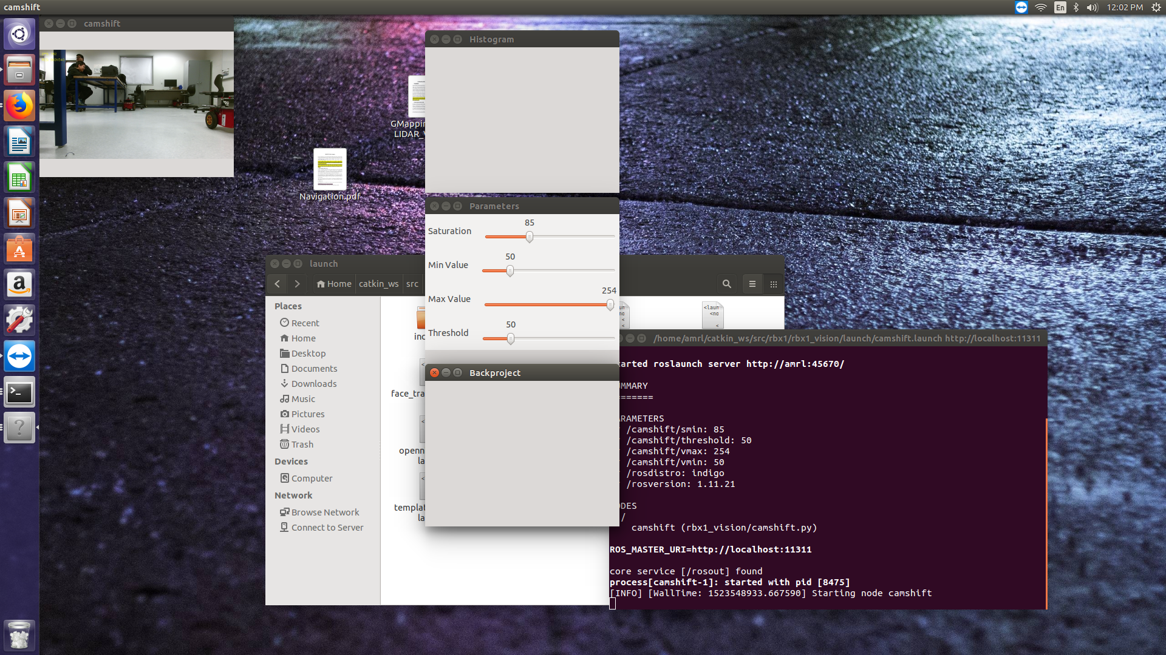

Fig.35. Get four window

$ roslaunch rbx1_apps follower2.launch

When we run this command, we can click the object, and the Pioneer P3-DX would follow the object.

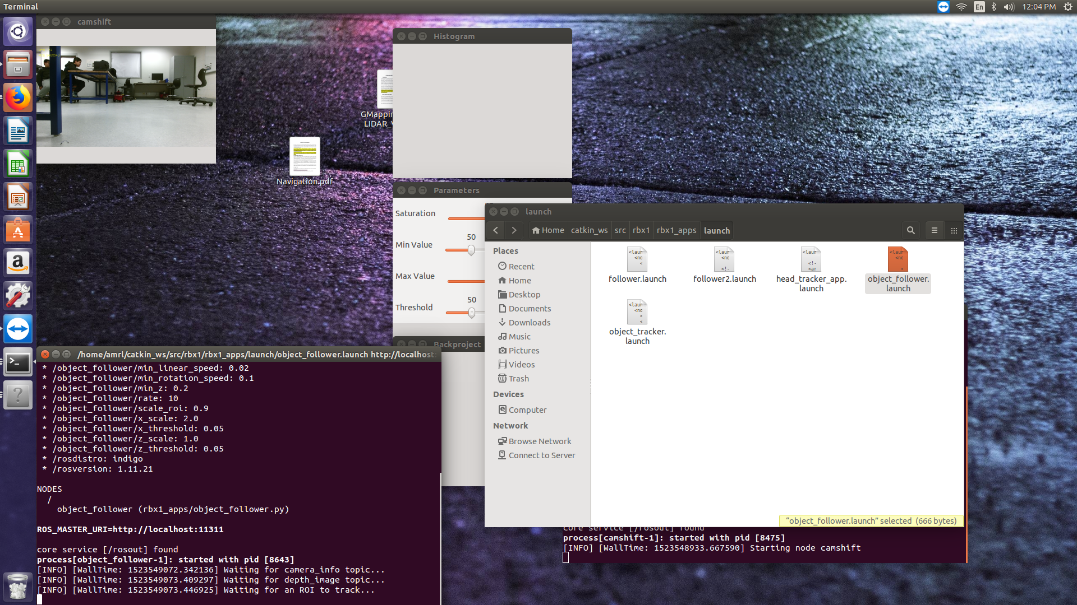

Fig.36. follow the object

1. Conclusion

Our group finally can use gmapping to create a map in an unknown environment. Then, we use the navigation package to set a goal, the Pioneer P3-DX will go to the goal by itself. During the path, Pioneer P3-DX is able to avoid the obstacles.

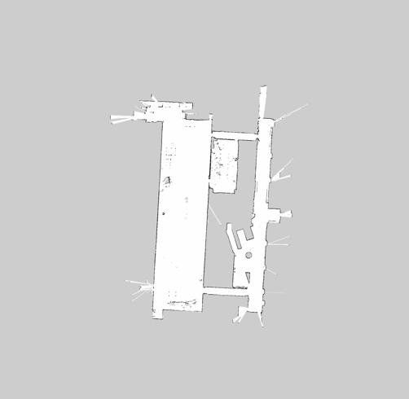

Fig.37. the map of first floor

Our group also can let the Pioneer P3-DX to recognize the stop sign and the Pioneer P3-DX will stop before the stop sign for 10 cm.

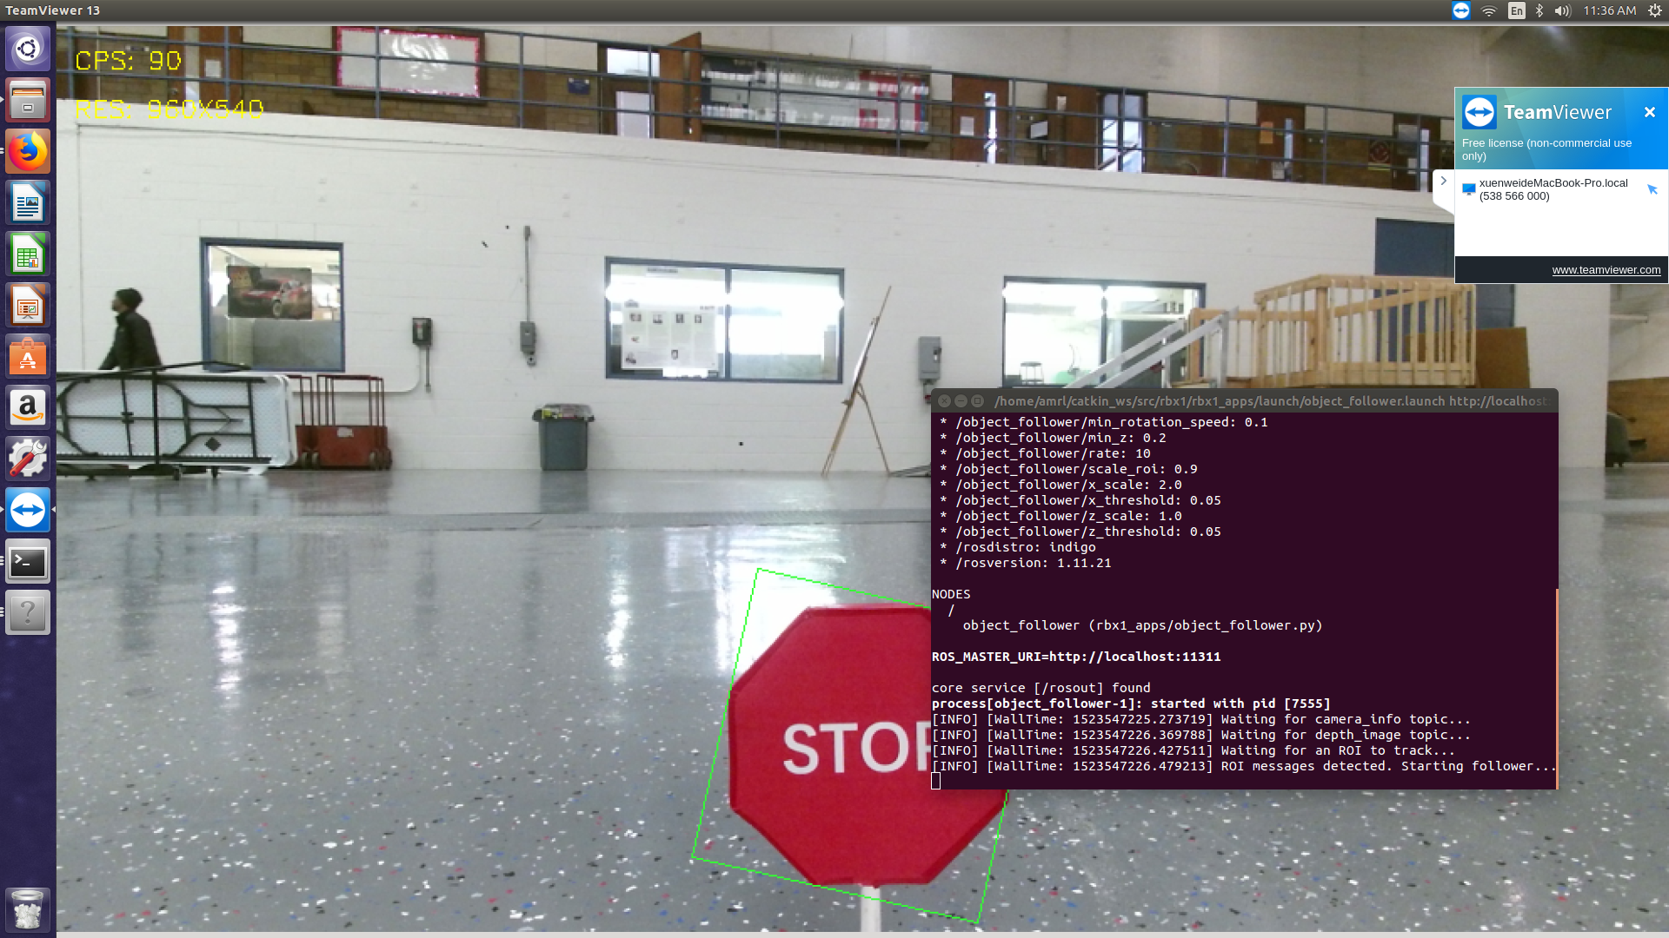

Fig.37. follow the stop sign

For the future, we will use the two packages at the same time. We will receive all the data together and then create a map, which include stop sign and traffic light.

1. REFERENCES

[1] http://www.mobilerobots.com/ResearchRobots/PioneerP3DX.aspx

[2] https://www.robotshop.com/en/hokuyo-ust-10lx-scanning-laser-rangefinder.html

[3] https://msdn.microsoft.com/en-us/library/jj131033.aspx

[4] http://wiki.ros.org/indigo/Installation/Ubuntu

[5] http://wiki.ros.org/ROSARIA

[6] http://ros.org/wiki/urg_node

[7] Rehatbil J N., “SLAM algorithm applied to robotics assistance for navigation in unknown environments”.

[8] No author. “Setting up your robot using tf” wiki.ros.org/navigation/Tutorials/RobotSetup/TF.

[9] http://wiki.ros.org/navigation

[10] http://wiki.ros.org/amcl?distro=indigo

[11] https://www.linuxidc.com/linux/2017-03/141955.htm

[12] http://www.coldvision.io/2016/06/27/object-detection-surf-knn-flann-opencv-3-x-cuda/

[13] Goebel, P. R. (2015). *ROS by example*. S.l.: Lulu

[14] https://github.com/pirobot/rbx1